Name: ADWAIT S PURAO

UID: 2021300101

Branch: Comps B (Batch B2)

**Verification of Thevenin’s, Norton’s and Maximum Power Transfer Theorem**

Page 1

**CIRCUIT DIAGRAM:**

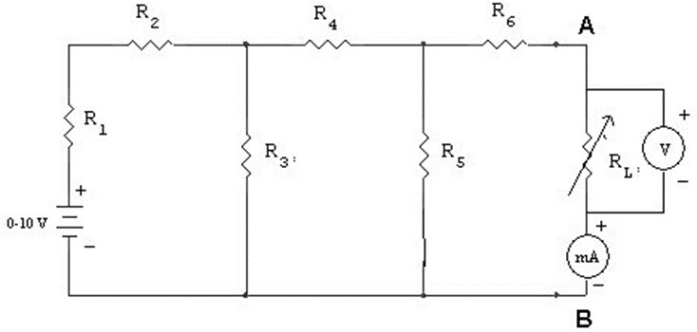

**OBSERVATIONS:**

# R1 = 0 Ω, R2 = 100 Ω, R3 = 330 Ω, R4 = 100 Ω, R5 = 330 Ω, R6 = 470 Ω, V1 = 10 V

|  |  |  |  |  |
| --- | --- | --- | --- | --- |
| **Sr. No.** | **RL (Ω)** | **VL (V)** | **IL (mA)** | **PL (mW)** |
| 1 | 383 | 2.046 | 5 | 10.23 |
| 2 | 403 | 2.088 | 5 | 10.44 |
| 3 | 423 | 2.146 | 4.95 | 10.62 |
| 4 | 443 | 2.202 | 5 | 11.01 |
| 5 | 463 | 2.246 | 5 | 11.23 |
| 6 | 483 | 2.275 | 5 | 11.375 |
| 7 | 503 | 2.360 | 4.75 | 11.21 |
| 8 | 523 | 2.405 | 4.6 | 11.063 |
| 9 | 543 | 2.451 | 4.5 | 11.029 |
| 10 | 563 | 2.497 | 4.4 | 10.987 |

|  |  |  |
| --- | --- | --- |
| **VTh (V)** | **RTh = RN (Ω)** | **IN (mA)** |
| 5.01 | 582 | 8 |

**CALCULATIONS:**

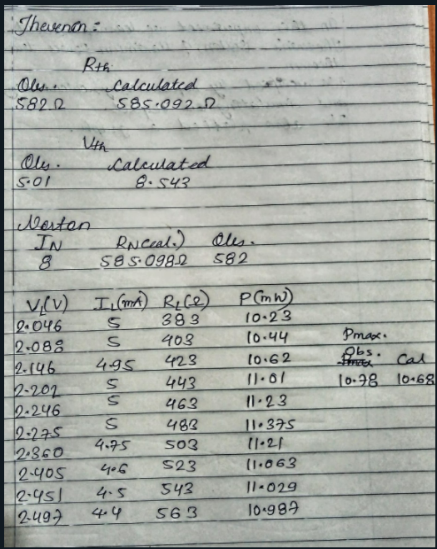

**EXPERIMENT NO.: 3 DATE: 20 / 06 / 2022**

**Verification of Thevenin’s, Norton’s, and Maximum**

**Power Transfer Theorem**

**AIM:**

To verify Thevenin’s, Norton’s, and Maximum Power Transfer Theorem for the given circuit by circuit implementation on breadboard and using simulator.

**APPARATUS AND COMPONENTS REQUIRED:**

Resistors, DC Voltage source, Ammeter, DMM, breadboard, connecting wires, Sequel Simulator

**THEORY:**

**Thevenin’s Theorem:**

Thevenin theorem is an analytical method used to change a complex circuit into a simple equivalent circuit consisting of a single resistance in series with a source voltage. Thevenin’s Theorem states that “Any linear circuit containing several voltages and resistances can be replaced by just one single voltage in series with a single resistance connected across the load “. In other words, it is possible to simplify any electrical circuit, no matter how complex, to an equivalent two-terminal circuit with just a single constant voltage source in series with a resistance (or impedance) connected to a load as shown below. Thevenin’s Theorem is especially useful in the circuit analysis of power or battery systems and other interconnected resistive circuits where it will have an effect on the adjoining part of the circuit.

Thevenin’s equivalent circuit:

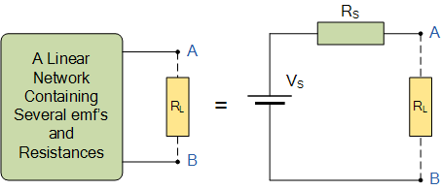

**Norton’s Theorem:**

Norton’s theorem is an analytical method used to change a complex circuit into a simple equivalent circuit consisting of a single resistance in parallel with a current source. Norton’s Theorem states that “Any linear circuit containing several energy sources and resistances can be replaced by a single Constant Current generator in parallel with a Single Resistor “.

As far as the load resistance, RL is concerned with this single resistance, RS is the value of the resistance looking back into the network with all the current sources open-circuited and IS is the short circuit current at the output terminals as shown below.

**Norton’s equivalent circuit:**

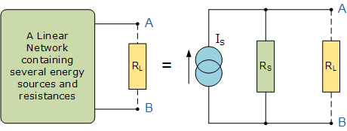

**Maximum Power Transfer Theorem:**

Maximum Power Transfer Theorem explains that to generate maximum external power through a finite internal resistance (DC network), the resistance of the given load must be equal to the resistance of the available source.

In other words, the resistance of the load must be the same as Thevenin’s / Norton’s equivalent resistance.

The fundamental Maximum Power Transfer formula is:

Pmax = VTh2 / 4RTh

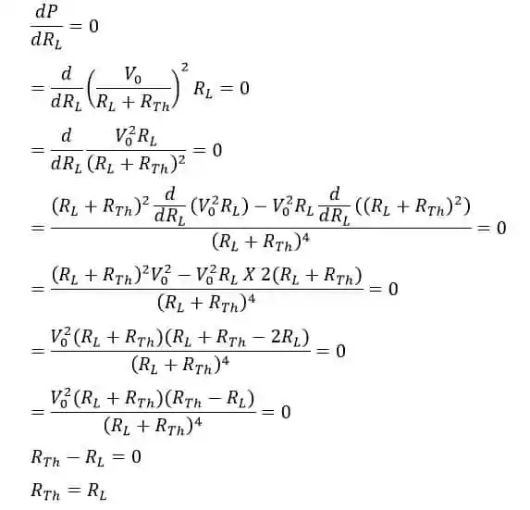

Therefore, the value of Pmax = I2R = [VTh / (RTh + RL)]2 * RTh = VTh2 / 4RTh

**PROCEDURE:**

1. Connect the circuit as shown in the circuit diagram.
2. Keep the voltage such that the maximum current does not go beyond the range of the milliammeter.
3. Vary the load resistance from minimum to maximum.
4. Note the corresponding load current (IL) and the voltage across the load VL.
5. Calculate the power dissipated in the load resistance as VL* IL.
6. Plot the graph of PL v/s RL.
7. Obtain observed values of VTh and RTh and I

8) Implement the given circuit using Sequel Simulator.

1. Simulate the circuit, find VTh, IN and get the graph of PL v/s RL

1. Verify with the theoretical solution.

**RESULT:**

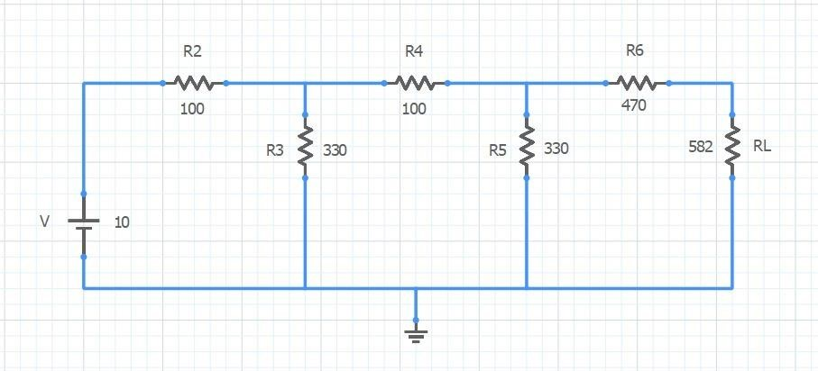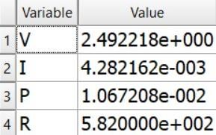

|  |  |  |  |  |  |  |  |  |  |  |  |
| --- | --- | --- | --- | --- | --- | --- | --- | --- | --- | --- | --- |
| **VTh (V)** | |  | **RTh = RN (Ω)** | | | **IN (mA)** | |  | **Pmax (mW)** | | |
| **Theoretical** | **Observed** | **By Simulation** | **Theoretical** | **Observed** | **By Simulation** | **Theoretical** | **Observed** | **By Simulation** | **Theoretical** | **Observed** | **By Simulation** |
| 5.00 | 5.01 | 5.00 | 585.098 | 582 | 585.098 | 8.543 | 8 | 8.543 | 10.68 | 10.78 | 10.68 |

**GRAPH:**

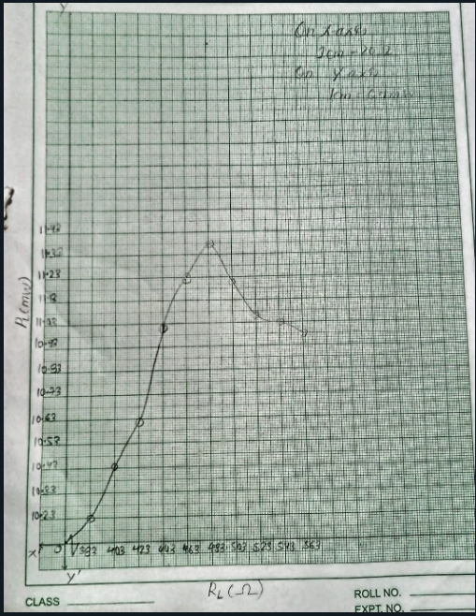

**CONCLUSION:**

